State University of New York at New Paltz

Student Name: James Smith
OS Lab section: 01 (Tuesday,3:30-6:20)
Semester: Fall 2020

REPORT for LAB # 01

(Unix Commands)

“Operating Systems” Fall 2020
(Professor Hanh Pham)

Lab Instructor: Madhu Rakshith Narasimharaju

UNIX Tutorial One

1.1 Listing files and directories

ls (list)
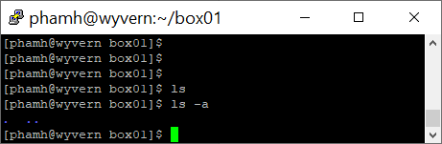

1.2 Making Directories

mkdir (make directory)




