**A) INSTRUCTIONS TO ACCESS YOUR CS ACCOUNT REMOTELY USING PUTTY (for Windows/PC)**

1)Search web for “putty”

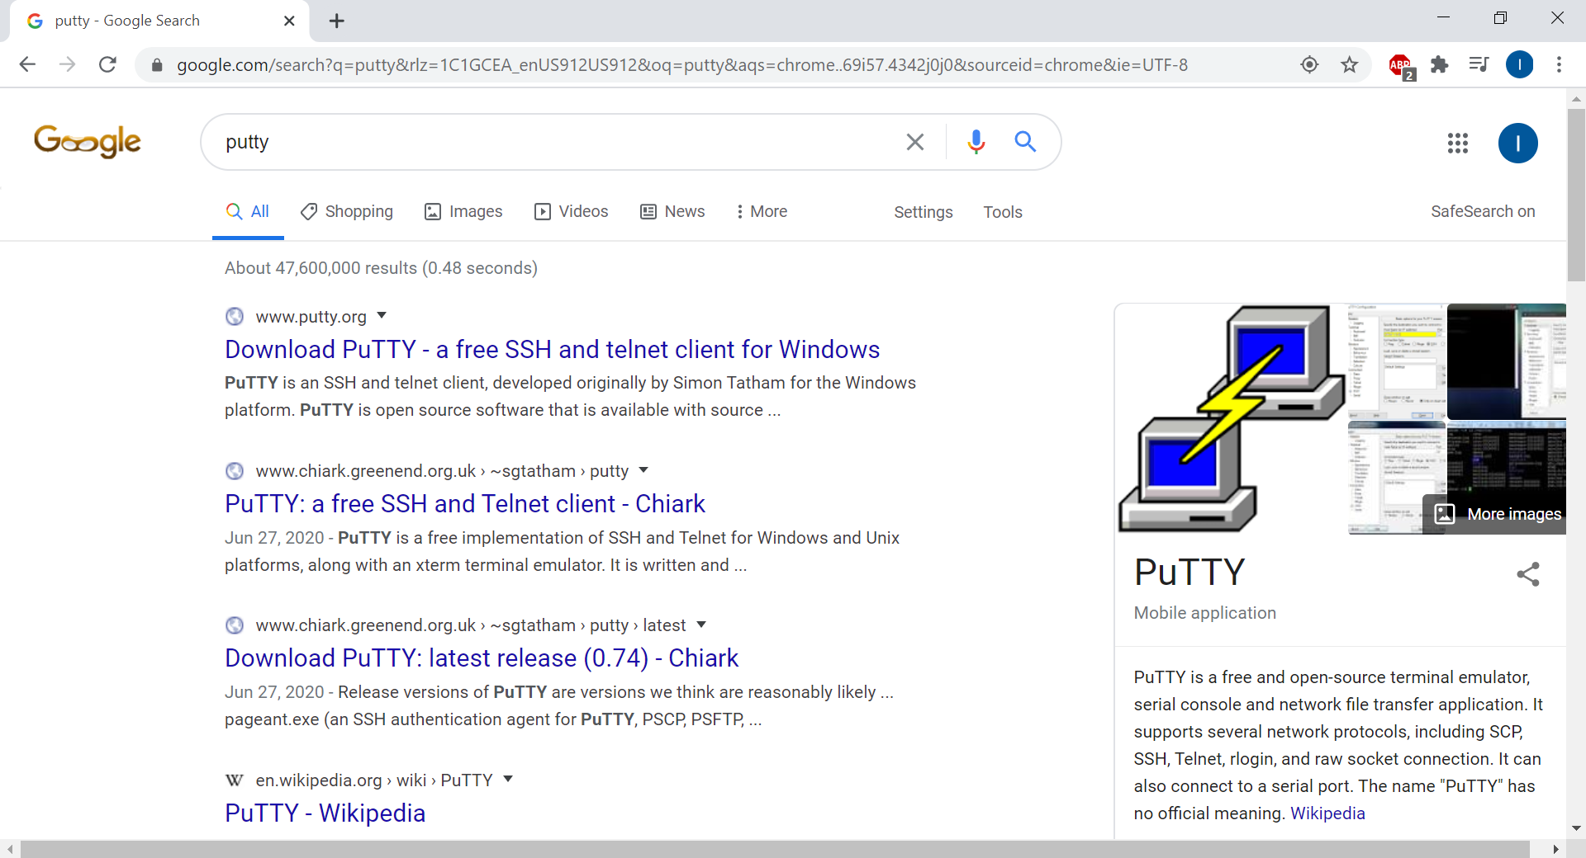

2) Download it (putty.exe) and move this file to a safe folder. Create a shortcut to this file for easy access.

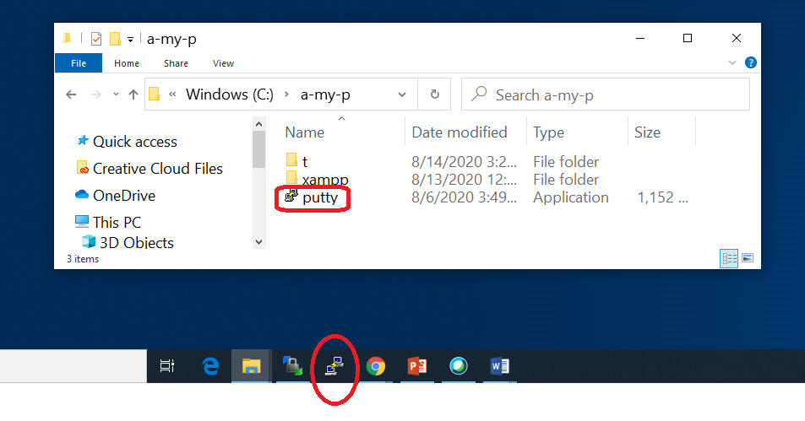

3) Run (double click) on “putty”

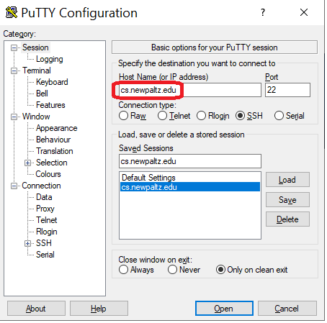

4) Login using the same username and password for Blackboard

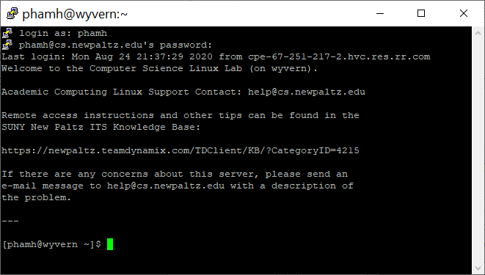

You are now at the CS server and can practice the UNIX commands.

**B) INSTRUCTIONS TO ACCESS YOUR CS ACCOUNT REMOTELY USING TERMINAL (for MAC OS)**

**1) Find** **Terminal in Mac os**

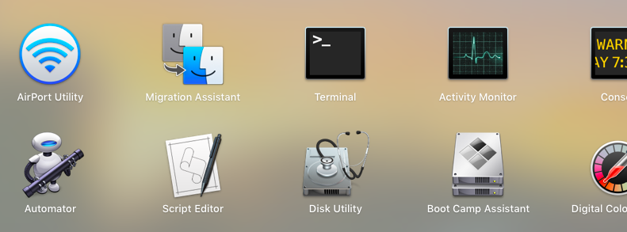

2) **TYPE command as shown below with your newpaltz username with domain name and enter the password to access the CS account:**

|  |
| --- |
| **ssh YourBlackboardU[serName@wyvern.cs.newpaltz.edu](mailto:username@wyvern.cs.newpaltz.edu)** |

Exp: if your username is smith01 then you should type:

**ssh smith01**[**@wyvern.cs.newpaltz.edu**](mailto:username@wyvern.cs.newpaltz.edu)

Then, press enter. It will ask for password just type the same password you use for Blackboard (you won’t be able to see the characters while typing). Then, you should see something like this:

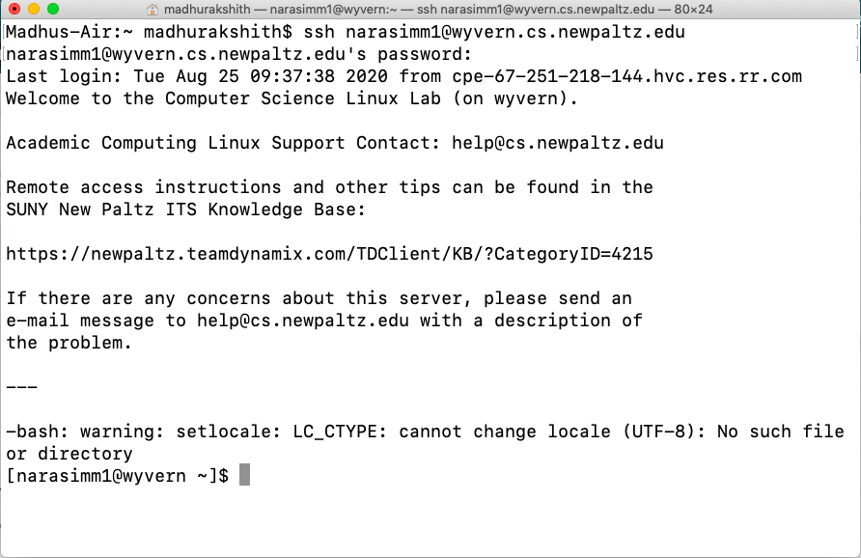

**CREATE & EDIT A TEXT FILE ON A UNIX SERVER**

Type this as command line:

|  |
| --- |
| jpico science.txt |

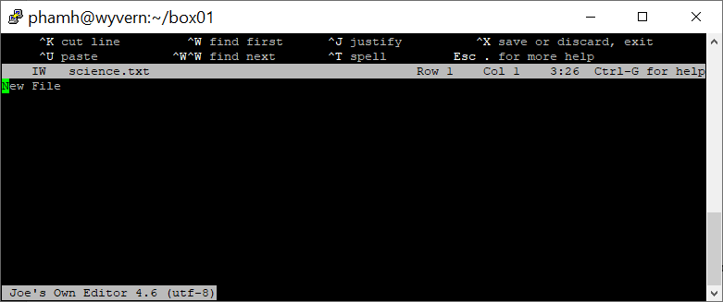

Type something:

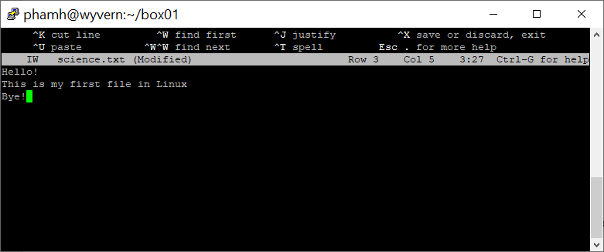

**JPICO Commands**

The bottom two lines in the PICO screen list Quick Command keys. PICO commands are used in conjunction with the Control key (**<Ctrl>** or **<control>** on a Macintosh), represented on the screen by the caret (**^**). The Control key is used like the Shift key; press and hold the Control key and then press the next character. For example, **<^x>** (**<Ctrl**+x> or **<control**+**x>**) means you should press and hold the Control key and then press the x key.

**Moving the Cursor**

* **<^b>** or **<left arrow>** moves left one character.
* **<^f>** or **<right arrow>** moves right one character.
* **<^p>** or **<up arrow>** moves up to previous line.
* **<^n>** or **<down arrow>** moves down to the next line.
* **<^a>** moves to beginning of line .
* **<^e>** moves to end of line.
* **<^v>** moves page down.
* **<^y>** moves page up (previous page).
* **<^l>** redraws the current screen.

**Deleting Text**

* **<backspace>** erases the character to the left of the cursor.
* **<^d>** deletes the character at the cursor position.
* **<^k>** deletes the entire line at the cursor position.
* **<^u>** undeletes (restores) the last line(s) deleted and places them at the cursor position.

**Saving a File**

* **<^x>** saves and exits PICO.
* **<^o>** saves as you are editing; allows you to change the file's name.

**Other Useful Commands**

* **<^t>** spell checks your text
* **<^w>** searches for text (i.e. “Where is?”). At the Search prompt, enter text in uppercase or lowercase.
* **<^r>** reads in a file from your home directory .
* **<^g>** accesses the online help. (**<^x>** exits help.)
* **<^j>** justifies paragraph.

To open a file in your UNIX directory press **<Ctrl**+**r>** (**<control**+**r>**). At the prompt File to insert from home directory, type the name of the file and press **<Enter>** (**<return>**). Or, press  **<Ctrl**+**t>** (**<control**+**t>**) to select the To Files option from the **<^r>** submenu. Use the arrow keys to highlight the name of the file to be read and press **<Enter>** (**<return>**).

**Save a File**

When you finish editing your file, press **<^x>** to exit PICO. You will see this message:

Save modified buffer (ANSWERING "No" WILL DESTROY CHANGES)?

Press the **<y>** key to save the file with your changes. PICO then prompts with:

File Name to Write: *filename*.

Press **<Enter>** (**<return>**) to keep the original filename.